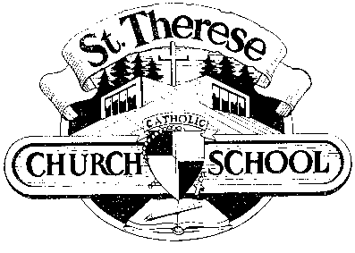
1260 NE 132nd Ave. Bus. Office 503-256-5850
Portland, Oregon 97230 School 503-253-9400
Rel. Ed. 503-256-5850

Financial Obligation Disclosure for 2019-20

During the 2019-20 school year, from June, 2019 to May, 2020, I agree to complete the following St. Therese School parent obligations:

- Registration form
- Tuition Contract
- Application Fee - $50 new students only
- Registration fee - $200 per student

St. Therese School takes the commitment to Catholic parishes seriously and expects parents to completely fulfill their obligations to ANY Archdiocese parish that awards them “qualified” status. In addition, tuition will be increased should a parish notify the school that the family is not fulfilling their commitment.
_____ Initial

K-8th Parents in addition throughout the year will meet these obligations:
- I agree to complete my Fair Share requirements (40 hours/20 hours single parent) by completing:
  - 10 volunteer hours for Fund Raising/Development (5 for single parent)
  - 30 volunteer hours for school-related activities (15 for single parent)
- I agree to complete the following Parent Club Fund Requirements:
  - Scrip/gift card requirement of a total of $2,000 per year ($1,000 for single parent). Buy-out from this program is $200 per year
  - Jog-A-Thon: Each family will solicit $150 in pledges (1st child, additional $50 per child, maximum obligation = $250).
  - Raffle:
Sell or purchase a minimum of $120 of raffle tickets.
  - Additional Fund Raising event(s) if needed

Preschool Parents throughout the year will meet these obligations:
  - 10 volunteer hours (See teacher for opportunities)
  - Raffle– sell or purchase a minimum of $30 of raffle tickets
  - Jog-A-Thon & Scrip purchases are optional – parents are encouraged to participate

______________________________ ____________________
Parent Signature Date

___________________________ __________________ _____
Print Name Oldest Student and Grade

RETURN THIS FORM WITH YOUR REGISTRATION PACKET

